Transforming Quadratics using the Casio ClassPad.

Directions:
- You are going investigate transforming (“changing”) quadratic functions.
- We will use the equation y = x2 as our main Function function.
- Read every line of this investigation carefully. Notice that the open circle symbol is used when there is a question for you to answer or a screenshot for you to add.

Introduction to Classpad
Turn on you Class pad
Tap on Menu
Select Graphs and Tables
Tap Edit, Clear All
Tap anywhere on the graph window at the bottom of the screen
Tap Edit, Clear All
All the grid and numbers should now be reset to original setting.
Type x $∧$2
Tap on box to left of the equation so tick appears
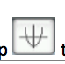
Tap to draw the graph.

Locate key features of the parabola:
- Horizontal intercepts: Tap Analysis, GSolve, Root.
  - Use the left and right cursor keys to move to each intercept.
- Vertical intercept: Tap Analysis, G-Solve, y-Intercept.
- Vertex: Tap Analysis, G-Solve, Min.

Now you are familiar with creating a graph on the class pad begin the investigation below.
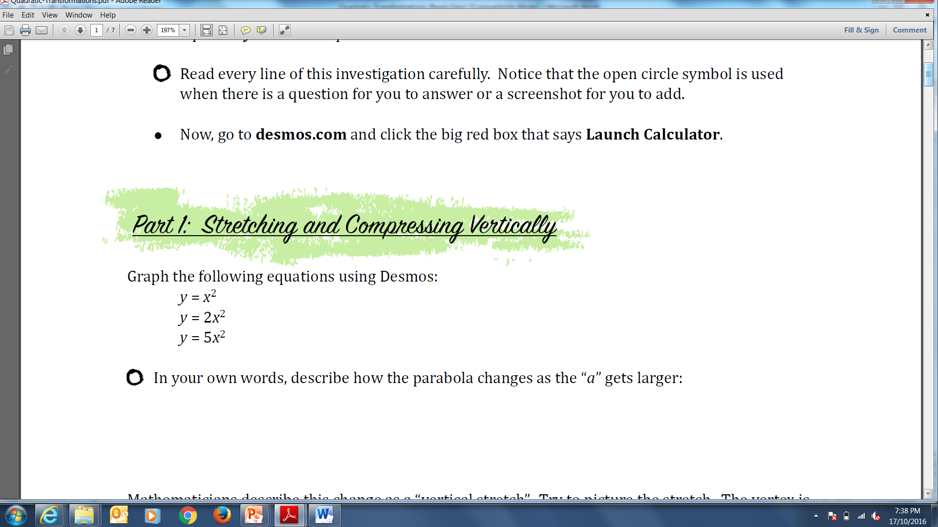

Graph the following equations using the ClassPad:
$y= x^{2}$
$y=2x^{2}$
$y=5x^{2}$

- Sketch the THREE graphs below. Don’t forget to label each parabola.
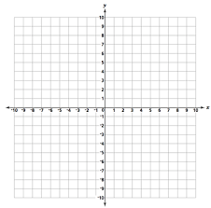

“a” represents the number in front of the x²

- In your own words, describe how the parabola changes as the “a” gets larger:

Mathematicians describe this change as a “vertical stretch”. Try to picture the stretch. The vertex is locked in at (0,0) and the parabola is stretched upward, making it skinnier.

We say the function is “stretched vertically by a factor of 2”.

- Write the equation that represents stretching $y=x^{2}$ by a factor of 6:

Delete all of the graphs in your ClassPad. Now graph the following equations:
$$y= x^{2}$$
$y=\frac{1}{2}x^{2}$
$y=\frac{1}{5}x^{2}$
- Sketch the THREE graphs below. Don’t forget to label each parabola.



- In your own words, describe how the parabola changes when “a” is a fraction between 0 and 1:

Mathematicians probably use a different description than we would. When 0 < a < 1, the function is said to be “compressed vertically”. Picture this: the vertex is fixed at (0,0) and it is pushed down (compressed), making the parabola wider.

If the equation is $y= \frac{1}{3}x^{2}$, we say the parabola has been compressed by a factor of 3.

- Write the equation that represents compressing y = x2 by a factor of 10:

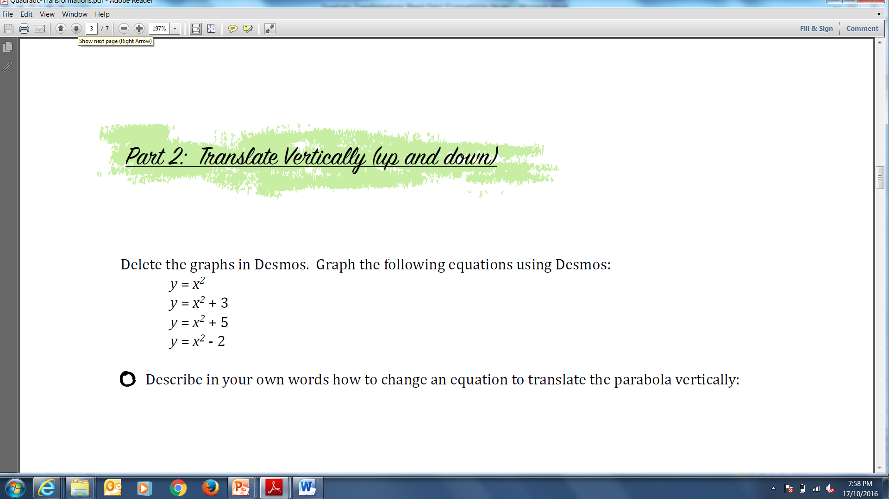

Delete all of the graphs in your ClassPad. Now graph the following equations:
$$y= x^{2}$$
$y=x^{2}+3$
$y=x^{2}+5$
$$y=x^{2}-2$$

- Sketch the graphs below. Don’t forget to label each parabola.



- In your own words, describe how to change an equation to translate the parabola vertically.

- Given the general function $y= x^{2}$, write the equation to translate the parabola vertically up 4 units and compressed by a factor of 3.

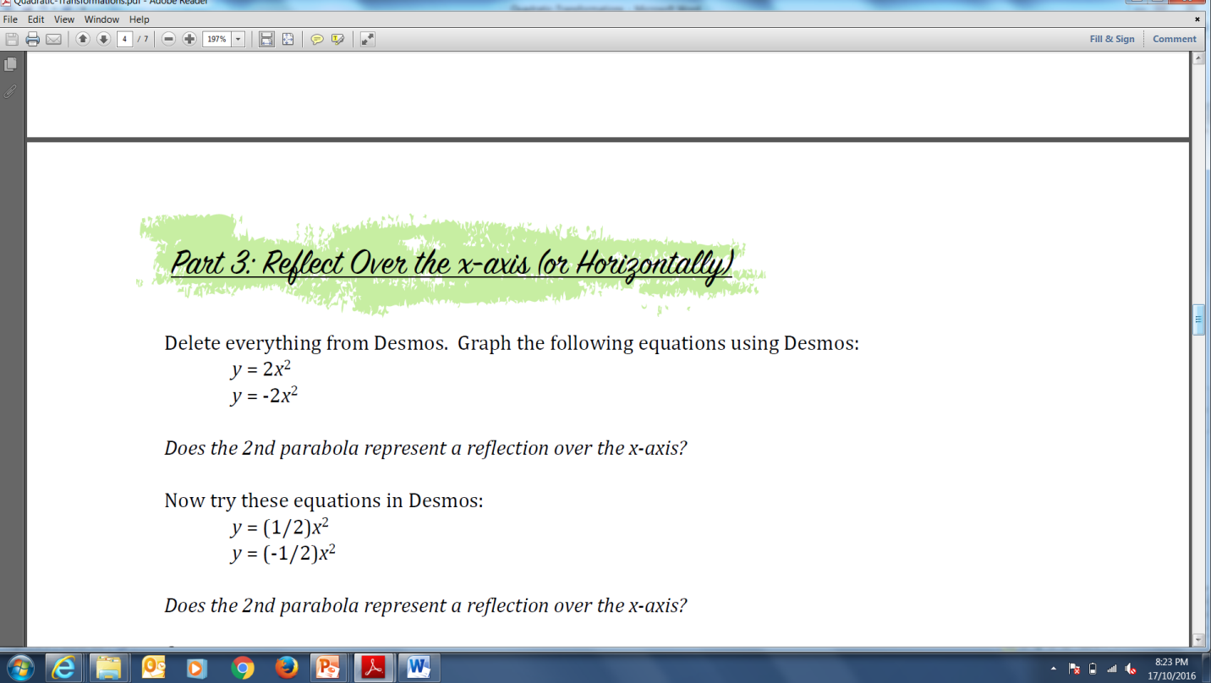

Delete everything in your ClassPad. Graph the following equations using:
$$y=2x^{2}$$
$$y=-2x^{2}$$

- Sketch the graphs below. Don’t forget to label each parabola.



Does the 2nd parabola represent a reflection over the x‐axis?

Now try these equations:
$$y=\frac{1}{2}x^{2}$$
$$y=-\frac{1}{2}x^{2}$$

Does the 2nd parabola represent a reflection over the x‐axis?

- Explain what “reflection over the x‐axis” means in your own words:

Now try this one:
- Given the general function, $y= x^{2}$, write the equation to vertically stretch the parabola by a factor of 4 and reflect it over the x-axis.

- Clear your ClassPad and graph the general function and your new function. Sketch the graphs below. Don’t forget to label each parabola.


Look at the new parabola. Is it vertically stretched by factor of 4 (this would make it skinnier)? Is it reflected over the x-axis?
Without graphing it, describe how this function: $y= x^{2}-1$ is transformed from the general function $y= x^{2}$.

Now check your description by graphing these to functions. Was your description correct?

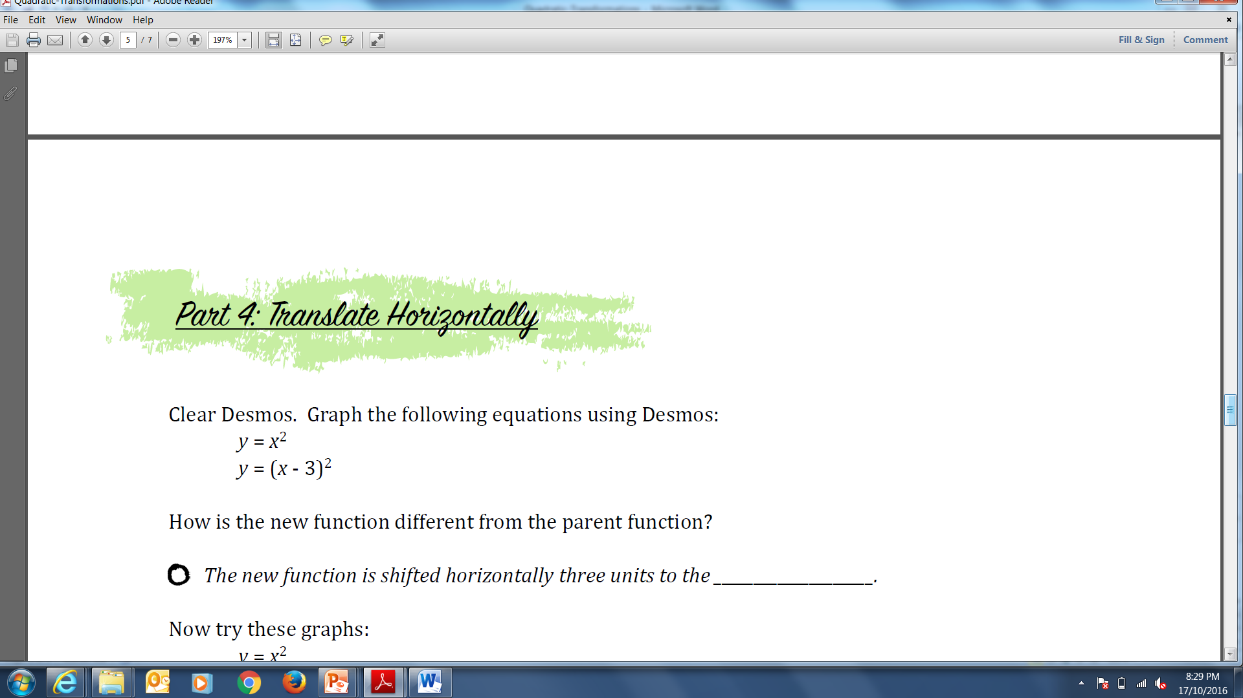

Delete everything in your ClassPad. Graph the following equations using:
$$y=x^{2}$$
$$y={(x-3)}^{2}$$

- Sketch the graphs below. Don’t forget to label each parabola.



How is this function different from the function equation?
- The new function is shifted horizontally three units to the ________________.
Now try these:
$$y=x^{2}$$
$$y={(x+ 3)}^{2}$$

- How is this function different from the function equation?

This one is tricky.
To shift right, change the x to (x minus a number). To shift left, change the x to (x plus a number).

- Write an equation to shift $y= x^{2}$ eight units to the left:

- Write an equation to shift $y= x^{2}$ eight units to the right:

- Clear your ClassPad and check that your equations are correct. Sketch the graphs below. Don’t forget to label each parabola.



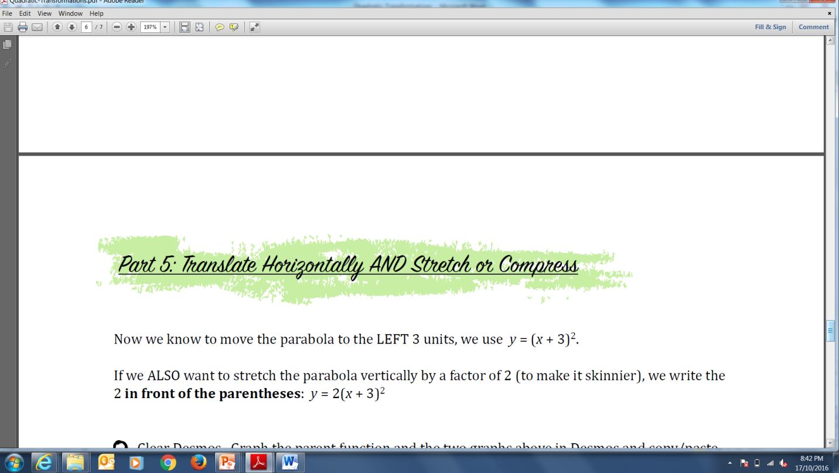

Now we know to move the parabola to the LEFT 3 units, we use $y=(x+3)^{2}$.

If we ALSO want to stretch the parabola vertically by a factor of 2 (to make it skinnier), we write the 2 in front of the parentheses: $y=2(x+3)^{2}$.

- Clear your ClassPad. Graph the general function and the two graphs above and sketch the graphs below. Don’t forget to label each parabola.



The whole shebang.

- Given the general function $y= x^{2}$, write the equation that will shift the parabola to the left 3 units, up 5 units, stretched by a factor of 2, and reflected over the x-axis:

- Clear your ClassPad. Graph your equation above. Were you correct? (If not, fix the equation). Sketch the graph below.



